Name: __________________________ Date: _______
Using Trigonometry to Find Area
- In , , , and 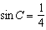. Find the area of .

- Gregory wants to build a garden in the shape of an isosceles triangle with one of the congruent sides equal to 12 yards. If the area of his garden will be 55 square yards, find, to the nearest tenth of a degree, the three angles of the triangle.

- In the accompanying diagram of parallelogram ABCD, , , and . What is the area of parallelogram ABCD?

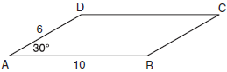

- Find, to the nearest tenth of a square foot, the area of a rhombus that has a side of 6 feet and an angle of 50°.

- The triangular top of a table has two sides of 14 inches and 16 inches, and the angle between the sides is 30°. Find the area of the tabletop, in square inches.

- The accompanying diagram shows the floor plan for a kitchen. The owners plan to carpet all of the kitchen except the “work space,” which is represented by scalene triangle ABC. Find the area of this work space to the nearest tenth of a square foot.

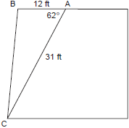

- If the vertex angle of an isosceles triangle measures 30º and each leg measures 4, what is the area of the triangle?

- The sides of a parallelogram measure 10 cm and 18 cm. One angle of the parallelogram measures 46 degrees. What is the area of the parallelogram, to the nearest square centimeter?

- The accompanying diagram shows a triangular plot of land that is part of Fran's garden. She needs to change the dimensions of this part of the garden, but she wants the area to stay the same. She increases the length of side AC to 22.5 feet. If angle A remains the same, by how many feet should side AB be decreased to make the area of the new triangular plot of land the same as the current one?

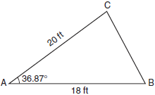

10. In , , , and . Find the area of , in simplest radical form.

- Two sides of a triangular-shaped pool measure 16 feet and 21 feet, and the included angle measures 58°. What is the area, to the nearest tenth of a square foot, of a nylon cover that would exactly cover the
surface of the pool?

- In , , , and . What is the area of ?

- A landscape architect is designing a triangular garden to fit in the corner of a lot. The corner of the lot forms an angle of 70°, and the sides of the garden including this angle are to be 11 feet and 13 feet, respectively. Find, to the nearest integer, the number of square feet in the area of the garden.

- In , , , and . Find the number of square units in the area of the triangle.

- In the accompanying figures of , , , and . Find the area of .

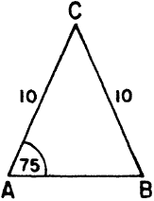

- The accompanying diagram shows the peak of a roof that is in the shape of an isosceles triangle. A base angle of the triangle is 50° and each side of the roof is 20.4 feet. Determine, to the nearest tenth of a square foot, the area of this triangular region.

